

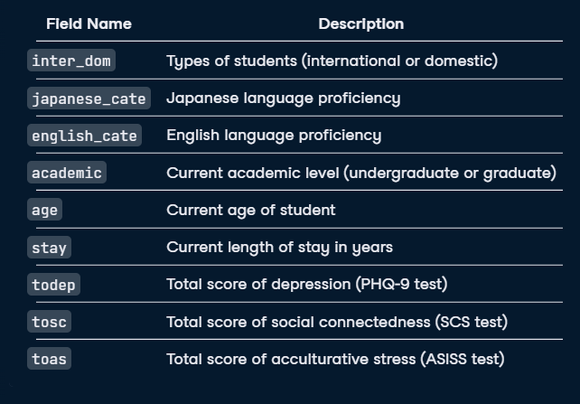

This is the given set of information on the following mental health regarding students. International students often face unique challenges, including mental health difficulties associated with acculturation stress and social connectedness. Using PostgreSQL, I aim to investigate whether international students experience higher rates of mental health issues compared to the general population and assess if the length of stay contributes to these challenges. 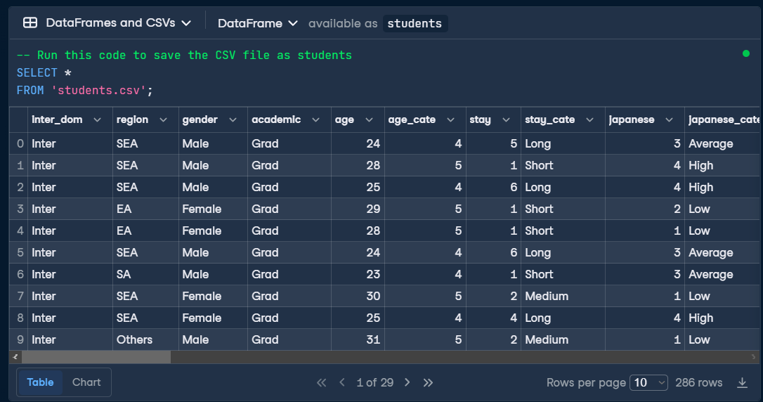

The following data shows how the data is extracted and accumulated from the students.csv, this has over 29 columns and 286 rows. We extracted the excel file to a normal table for sql to use it as a student document.

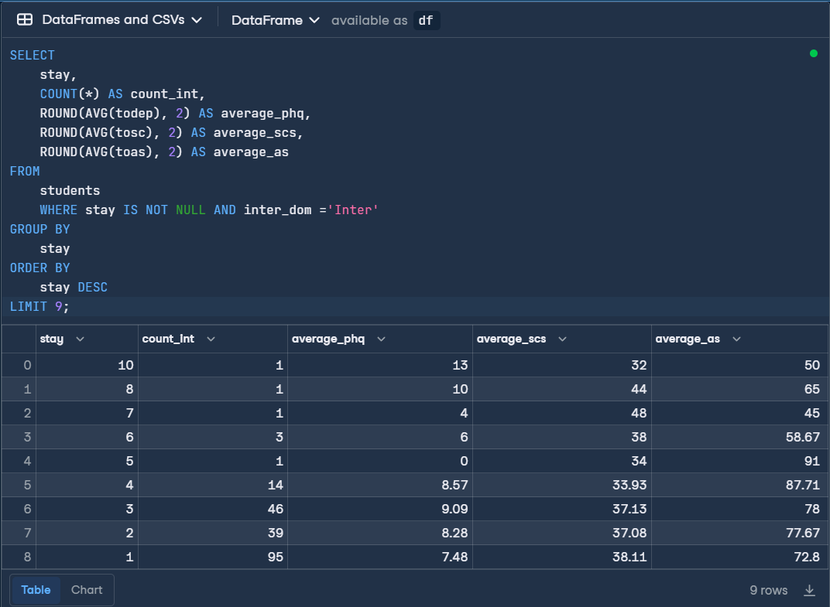

The following code shows how the data is selected and it is counted as whole to represent the unique id as count_int, and the data of the total depression is averaged with the function representing the AVG and round function gives 2 of the decimals rounded. It is given as alias average_phq, same as total social connections aliased as average_scs and total acculturative stress aliased as average_as are also averaged and rounded to 2 decimal numbers. Here are some graphical representations for the given data set.

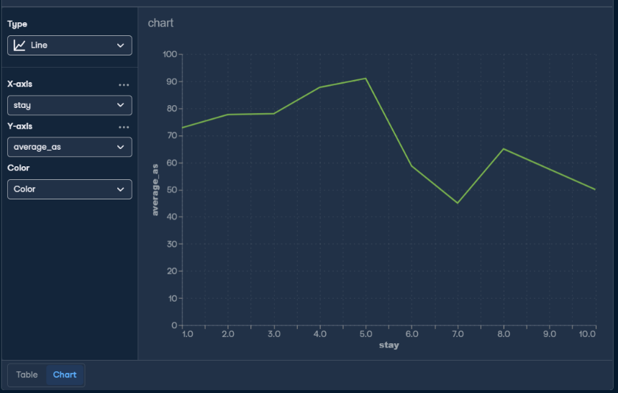

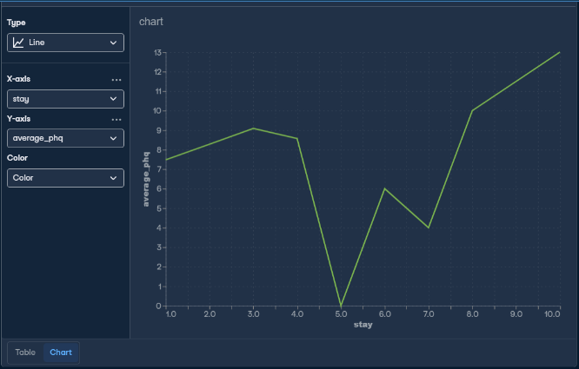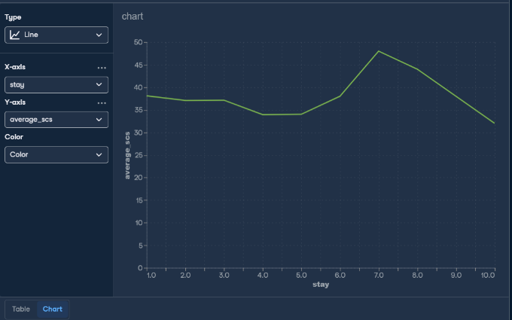

Length of Stay Distribution: The data is grouped by the length of stay (stay) of international students in the host country. Each group represents a specific duration of time spent by students in the host country, with the groups likely representing different cohorts based on their length of stay.

Sample Size Variation: The count of international students (count_int) varies across different lengths of stay. This indicates that the number of students in each group differs, suggesting unequal representation of students across different durations of stay.

Mental Health Indicators: The average scores for mental health indicators are calculated for each group. These indicators include the Patient Health Questionnaire (PHQ), Social Connectedness Scale (SCS), and Acculturative Stress Scale (AS). The rounded average scores (average_phq, average_scs, average_as) provide insights into the mental health status, social connectedness, and acculturative stress levels of students in each group.

Descending Order of Length of Stay: The results are ordered in descending order of length of stay (stay DESC), allowing for a clear comparison of mental health indicators across different durations of stay, from longer stays to shorter ones.

Limitation: It's important to note that the query limits the results to only the top 9 durations of stay (LIMIT 9). This might exclude certain durations, potentially impacting the comprehensiveness of the analysis.

In conclusion, this analysis provides valuable insights into the relationship between the length of stay of international students and their mental health indicators. However, further exploration and statistical analysis may be necessary to determine any significant associations or patterns between length of stay and mental health outcomes among international students.